**Thompson Sampling Intuition**

* We will use this algorithm to solve the multi-armed bandit problem.
* We have *d* arms. For example, arms are ads we display to users each time they connect to a web page.
* Each time a user connects to this web page, that makes a round.
* At each round *n*, we choose one ad to display to the user.
* At each round *n*, ad *I* gives reward 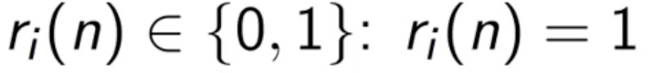 if the user clicked on the ad *I*, 0 if the user didn’t.
* The goal is to maximize total rewards received over many rounds.

**Thompson Sampling Algorithm –**

**Step 1:** At each round n, we consider two numbers for each ad i:

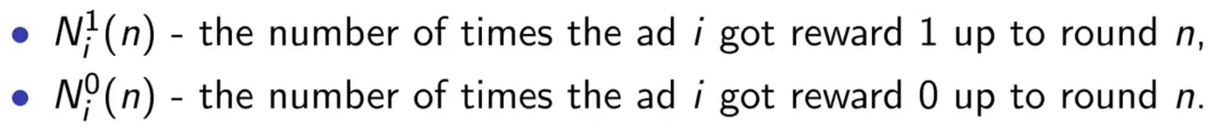

**Step 2:** For each ad i, we take we take a random draw from the distribution below:

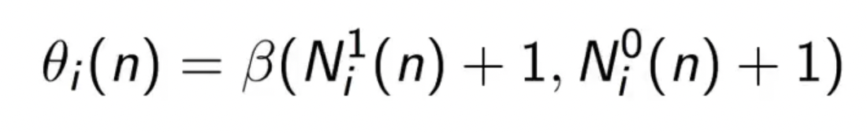

**Step 3:** We select the ad with highest $θi\left(n\right).$

**Thompson Sampling Intuition:**

* Here, we have got a scale, and the vertical axis (the y-axis) represents the expected return value of each bandit.

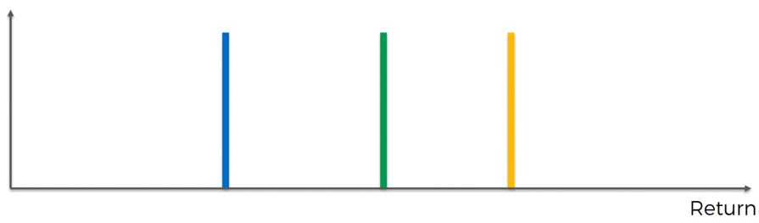

* And each of the machine has a distribution behind it, and the amount of money you win from the machine is picked from a random distribution behind each machine which we are unaware of (the lines plotted are the mean values of the distributions and are shown only for understanding).
* Since, all the machines seem identical, we must have a couple of trial rounds just to get some data to analyze.
* Let’s say we have run a couple trial rounds for each machine, based on those trial runs the algorithm will construct a distribution, and this where the Thompson Sampling algorithm starts being different from the Upper Confidence Bound Algorithm.

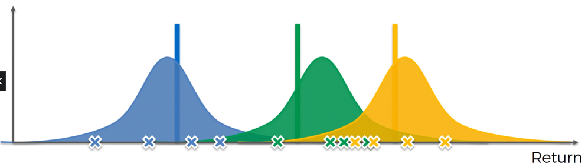

* The actual meaning of this distribution is not what you might think at first.
* Once we have constructed the distributions from running couple of trial rounds, we might assume that the purpose of those is an attempt at guessing the distributions behind the machines.
* That is not the case. We are constructing something completely different; we are constructing a distribution of where we think the actual expected value might lie.

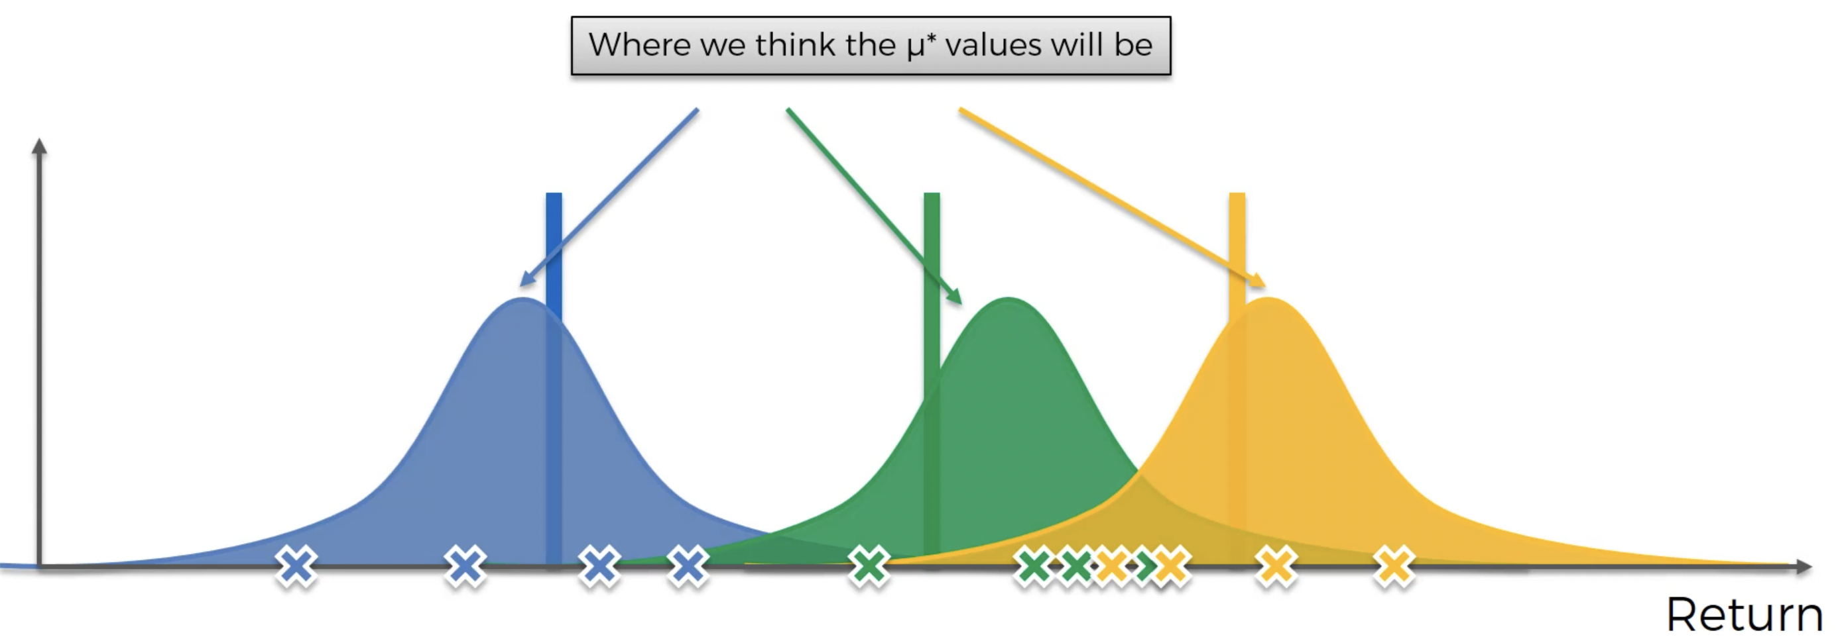

* This is where we think the actual expected values will be.
* Just to reiterate – we are not trying to guess the distributions behind the machines, we are trying to mathematically explain what we think could be going on. Because this also demonstrates that the Thompson sampling is a probabilistic algorithm. The upper confidence bound was a deterministic algorithm where everything was strict – whichever has the highest confidence bound will be chosen.
* But here, we are creating a probabilistic perception of the world.
* During each new round, Thompson Sampling Algorithm will trigger these predicted distributions, and pull a value from each predicted distribution.

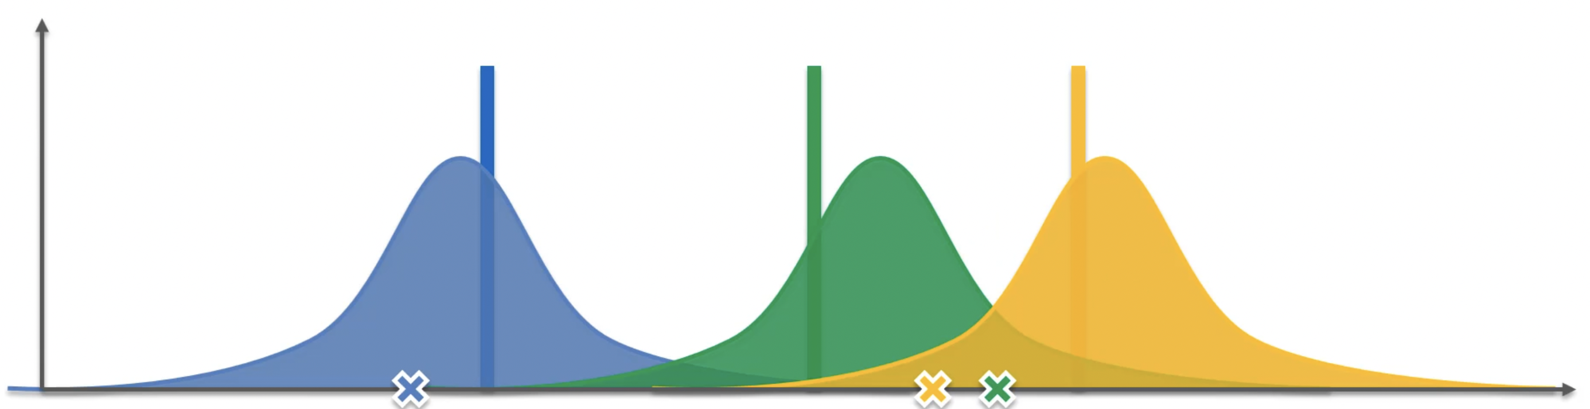

* By pulling all those values, we have generated our own bandit configuration. So, we have created our own batch of machines in our own virtual world. And the obvious way of solving the bandit problem from the predicted distribution is to pick the value with highest return i.e., the green value.
* Then the machine will implement the virtual solution in the real world and pull the lever for the green machine. The value of the green machine will be based on the actual distribution (the vertical green line – the mean of the distribution of the green machine) and not the predicted one.

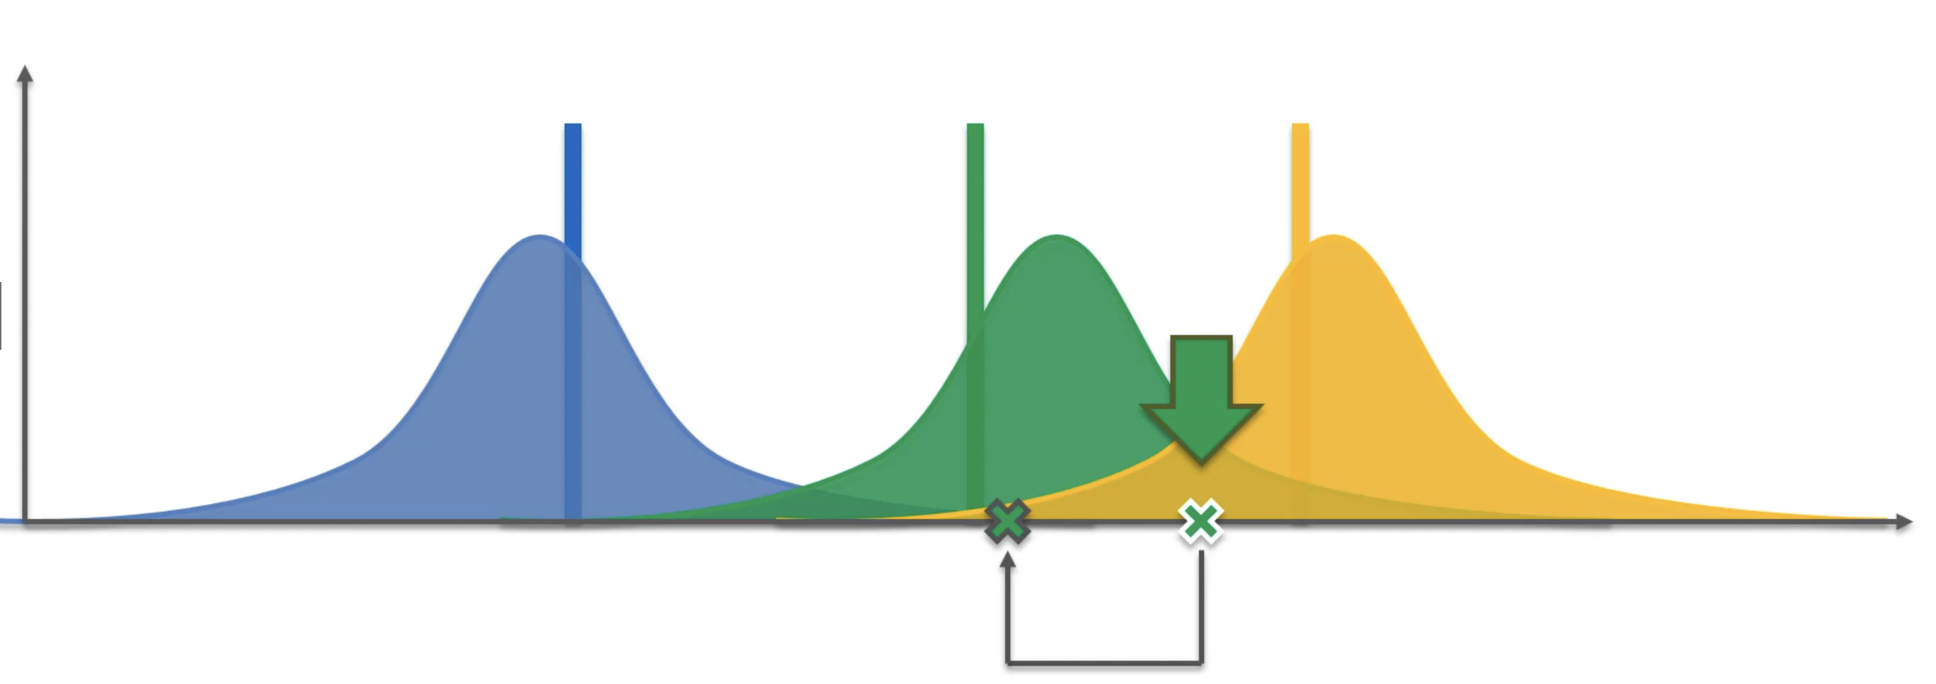

* Now, this is a new piece of information for the algorithm. And as the actual value of the machine was different than the predicted one, the algorithm will adjust the perception of the real world. So, it will add that new information into the existing probability distribution and see how it changes the perception.
* What will happen then is the predicted distribution will change for the green one and become narrower because we have more information, and the sample size has increased.

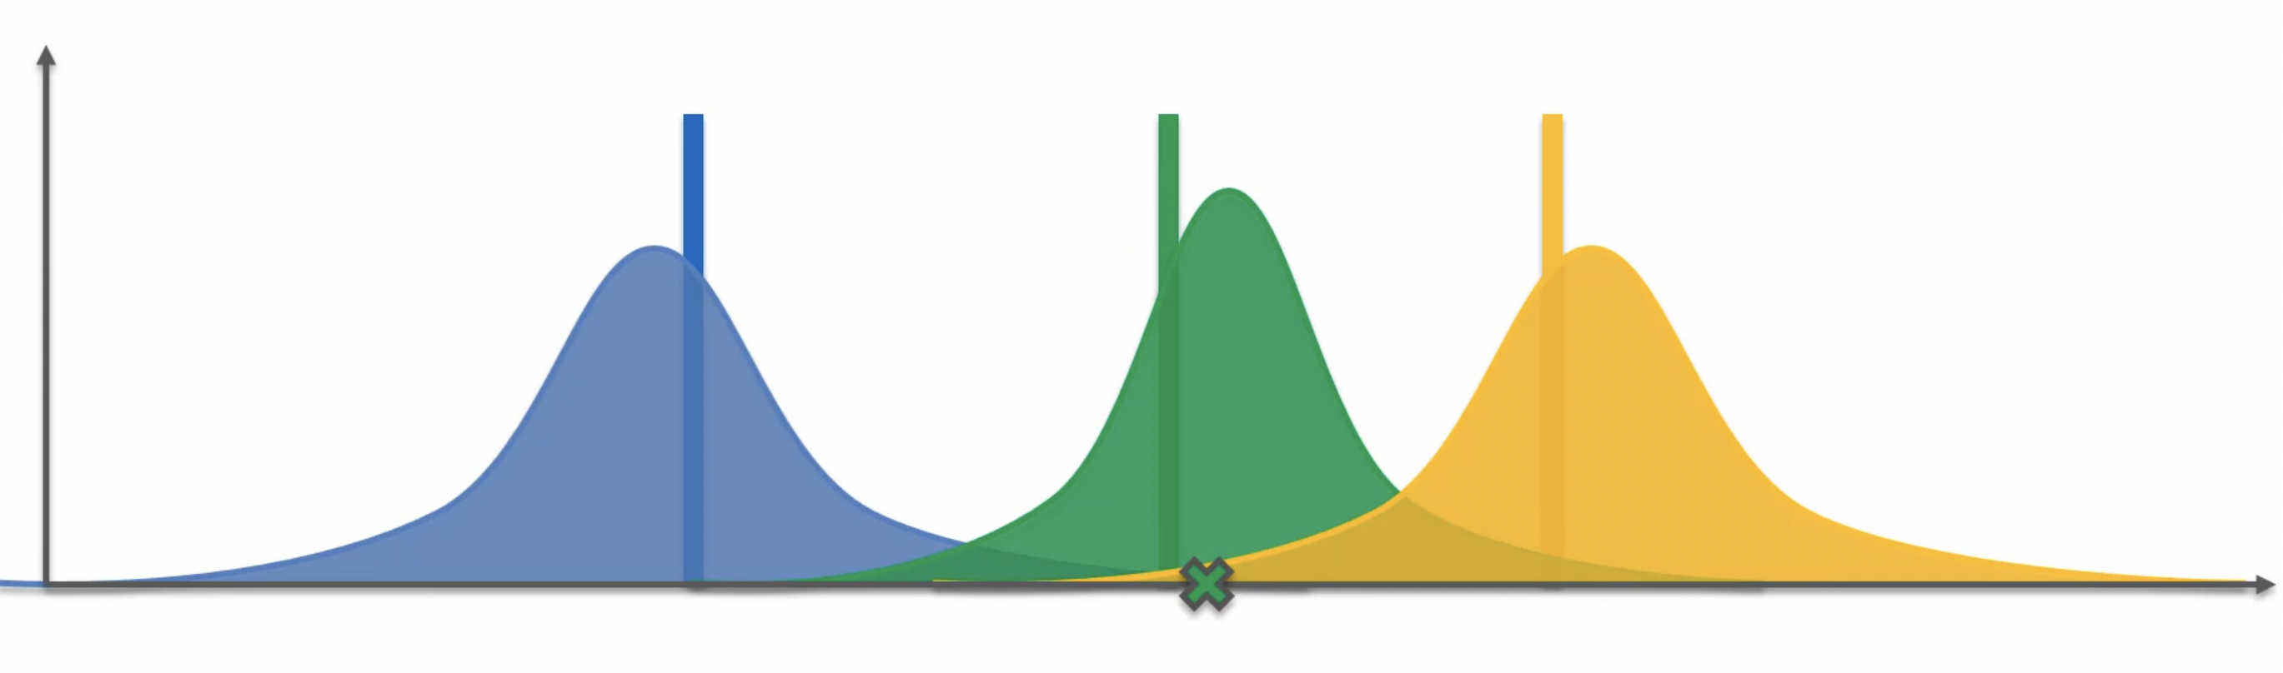

* Of course, it won’t change that much in the real-world implementation, this is just to explain the point. But the point is the distribution will become narrower and converge gradually close to the actual distribution.
* Next, there is a new round. We are going to do the same thing for the new round. Again, we generate and pick new values for the new round. And again, we generate our own bandit configuration in our hypothetical world.

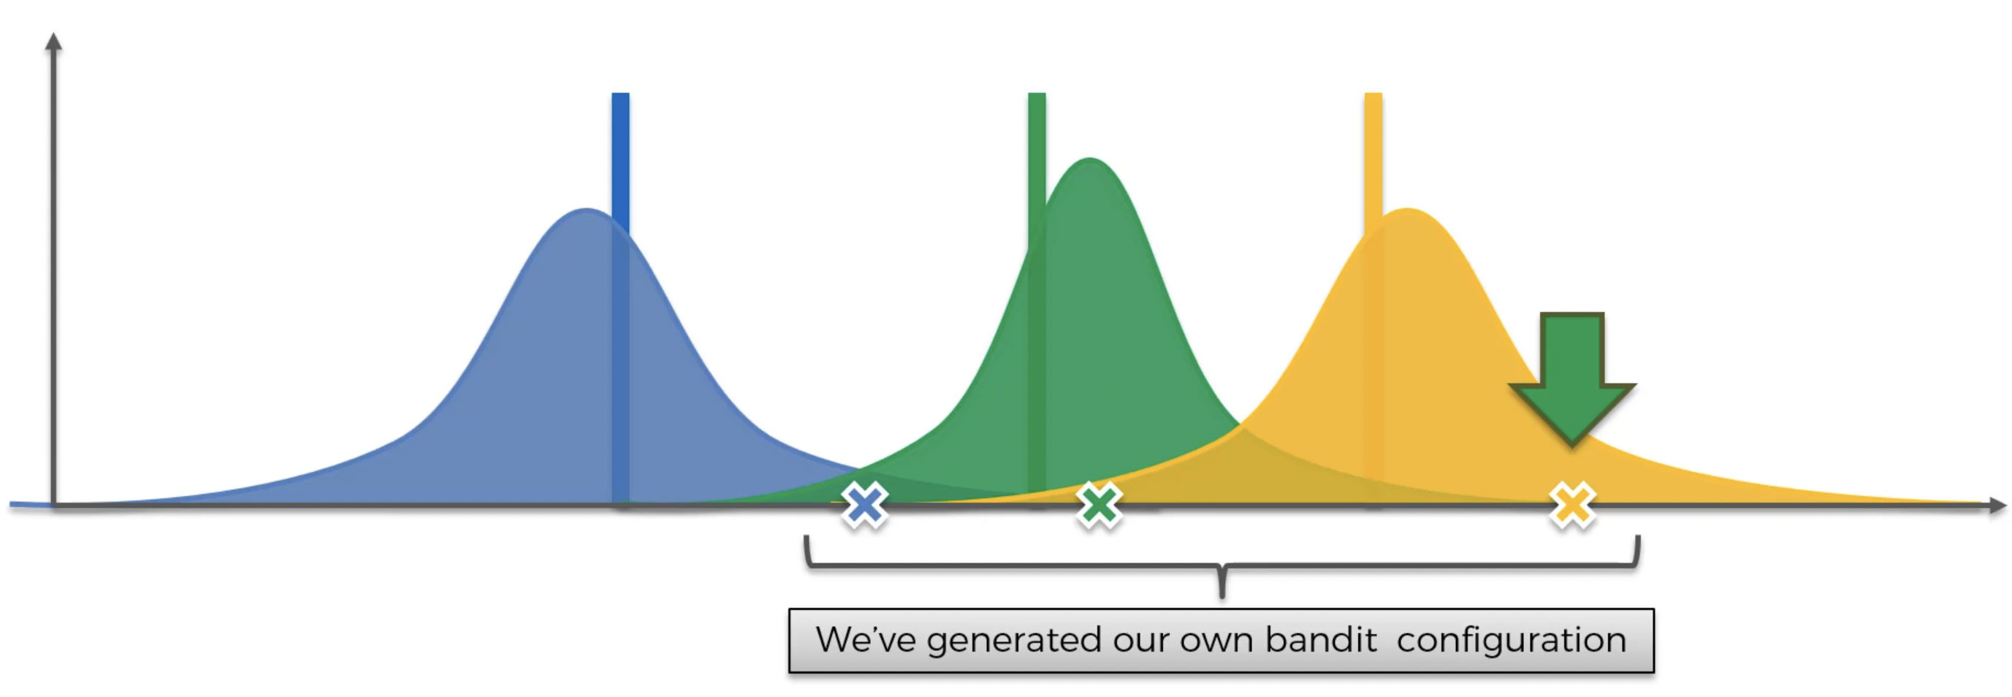

* Since, the yellow band has the highest predicted value, we will pull the lever of that machine and that’s going to trigger the distribution behind the yellow bandit which will give us the actual value of that machine.

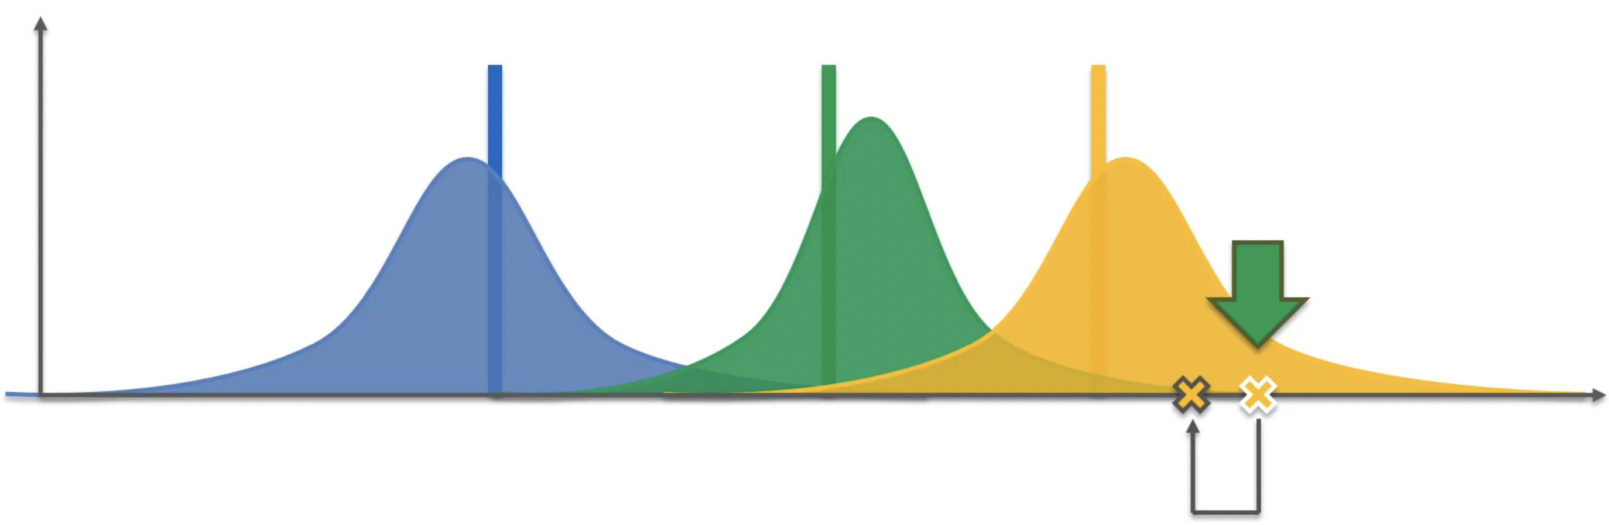

* Now we are going to incorporate that value into our perception of the world, and it will adjust based on the real-world output.

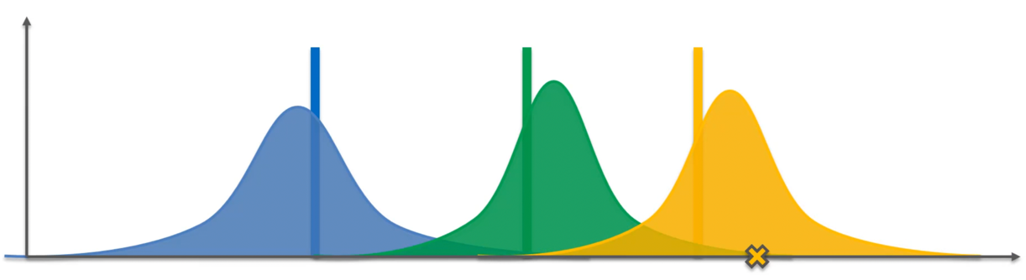

* Then we perform a new round of prediction, and it generates new values of our own bandit configuration. Again, in that configuration the value of, let’s say, yellow machine would be the highest, and we pull the lever of the yellow machine in the real world. Then the value of the real-world distribution would be shown, and we will adjust the predicted distribution based on those values.
* And we will keep doing that where we have refined the distribution substantially and the distribution looks something like this:

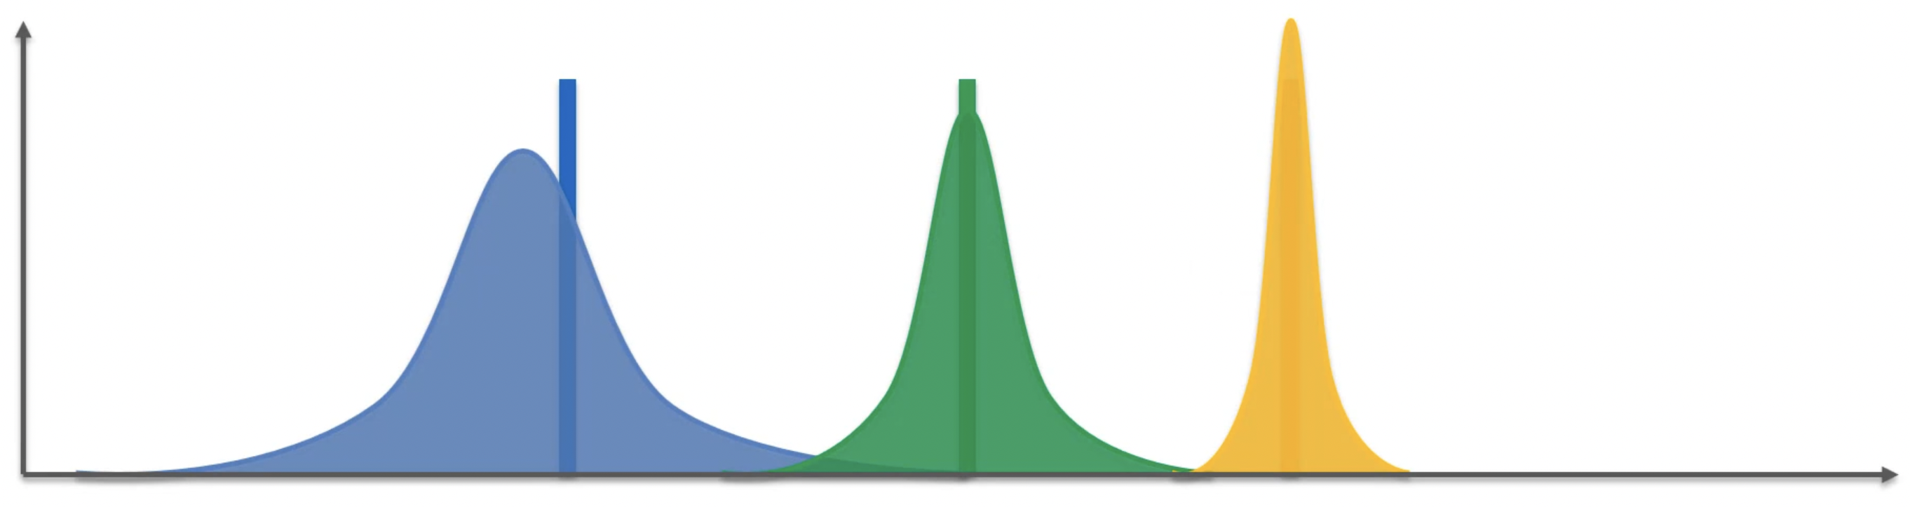

* Some of the machines will be refined more, some less, and that is because we will keep generating values for the machines producing the highest values and in our case that would be the yellow machine. In the long run, the other two machines might not even get that refined, and that is totally fine because our point is to get to the best machine and exploit it as much as we can.

**UCB VS Thompson Sampling:**

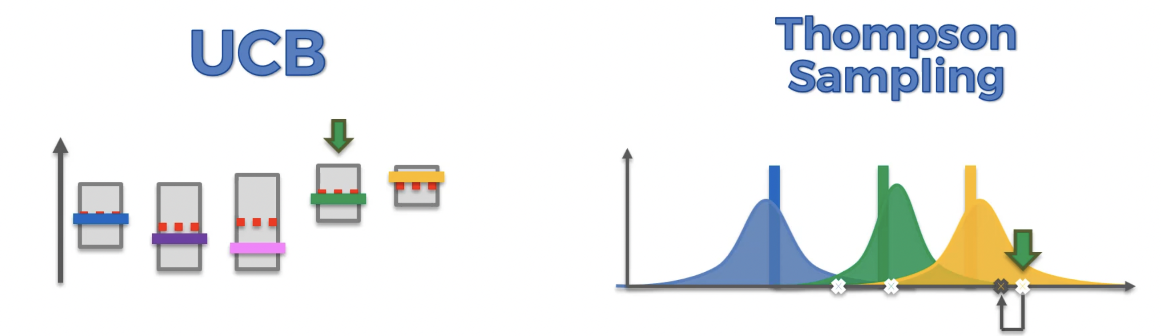

* The first characteristic that is different is that UCB is a deterministic algorithm. What it means is that it is very straightforward. At certain round what is going to happen is that the machine with the highest upper confidence bound will be picked. Yes, there is a randomness when we pull the lever and the actual value is generated, but that randomness is on the side of the machine. Whereas, on the other hand Thompson Sampling is a probabilistic algorithm because in the algorithm itself it has this probability distribution which represents our perception of the world and where we think the actual expected returns of each machines lie and therefore, every time we are implementing or iterating the Thompson Sampling algorithm, we are generating random values from those distributions. So, if you re-run a round in the UCB algorithm, just one given round. after you have received the value from the previous value from the machine it is always going to be same result. Whereas, in the Thompson Sampling Algorithm every time we re-run the round after receiving the actual values from the previous round, it is always going to be different because we always from our distribution which characterize our perception of the world. And that is a whole different type of algorithm – it is a probabilistic algorithm.
* And those two things have a few different implications. For instance, an important one is that UCB requires an update after every round. So, basically the value that you get back from the machine, that value must be incorporated right away. You cannot proceed to the next round until you have incorporated that value and made an adjustment to the algorithm because if you don’t make the adjustment nothing changes, and you will be stuck. Whereas. Thompson Sampling can accommodate delayed feedback. This means that, if you pull the lever and you only will only know the result not right away, but 500 rounds later, the Thompson Sampling Algorithm will still work because if you run the algorithm without updating the perception of the world, you are still going to get a new set of hypothetical bandits, you are going to generate a new set of expected returns for every bandit as you are generating them in a probabilistic manner. And this gives an advantage to the Thompson Sampling Algorithm because you don’t have to update the algorithm with the result every time.
* And finally, Thompson Sampling Algorithm has better empirical evidence than UCB because up until recently the theory/research behind the Thompson Sampling Algorithm wasn’t completed, it was only researched in-depth just a few years ago, and now you can find a lot of information on Thompson Sampling Algorithm. Previously people would just see that Thompson Sampling Algorithm does work better than UCB from experimental evidence